LAB ASSIGNMENT 2

Tejaswi Ayyadapu

Student ID: 16278799

Question 1 :

Installed R
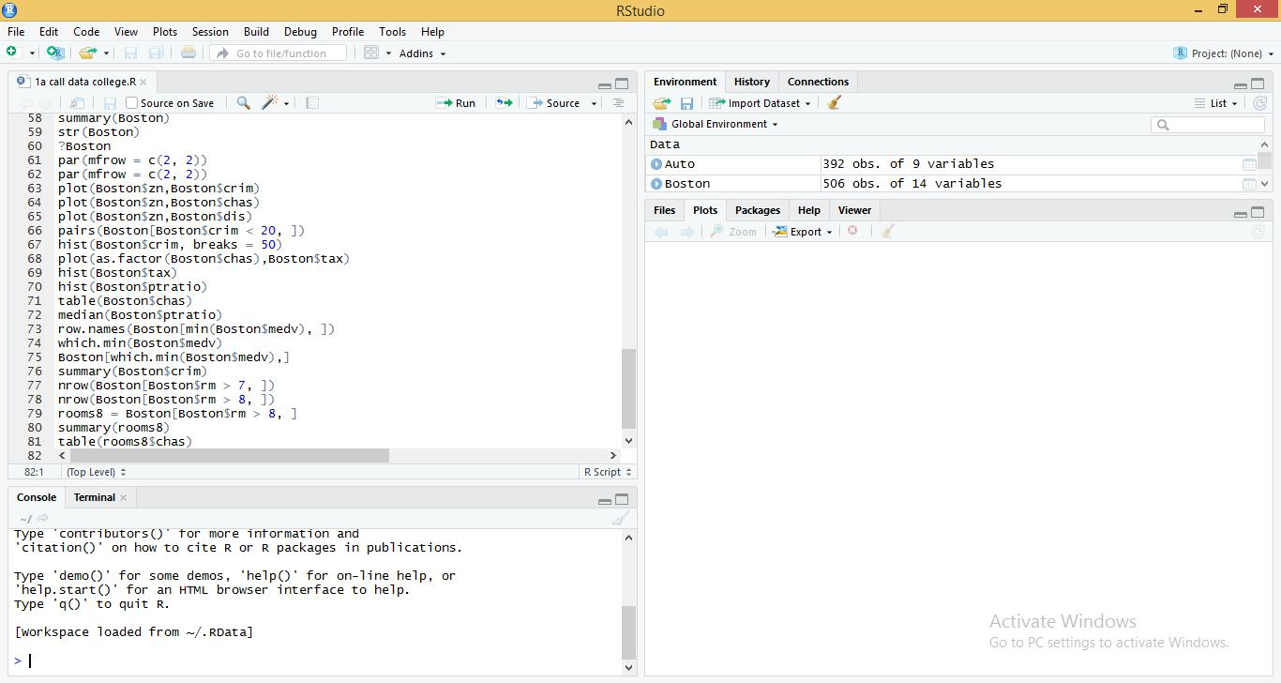

Question 2:

2.a.i

i. Is there a relationship between the predictor and the response?

library(ISLR)
data(Auto)
fit <- lm(mpg ~ horsepower, data = Auto)
summary(fit)
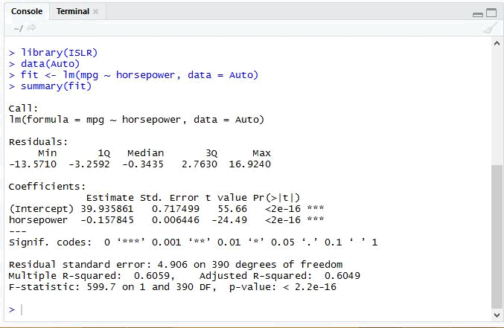

Yes, there is a relationship between the predictor and the response as the P value is less than 0 for the corresponding F statistic.

2.a.ii

How strong is the relationship between the predictor and the response?
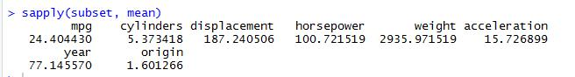

Mean:

The mean of mpg is 23.4

They have a strong relationship, as the RSE is very low at 4.906 and the adjusted R-square 60% of the variability between the predictor and the response .
2.a.iii

Is the relationship between the predictor and the response positive or negative?

The relationship is negative as the coefficient of “horsepower” is negative. When the automobile has more horsepower the linear regression indicates the less mpg fuel . we can understand that the expected change in response mpg for a 1 unit change in horsepower is - 0.16.

2.a.iv

predict(fit, data.frame(horsepower = 98), interval = "confidence")

predict(fit, data.frame(horsepower = 98), interval = "prediction")
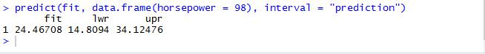
2.(b)

Plot the response and the predictor. Use the abline() function to display the least squares regre ssion line

plot(Auto$horsepower, Auto$mpg, main = "least sqaures regression line", xlab = "horsepower", ylab = "mpg", col = "blue")

abline(fit, col = "red")
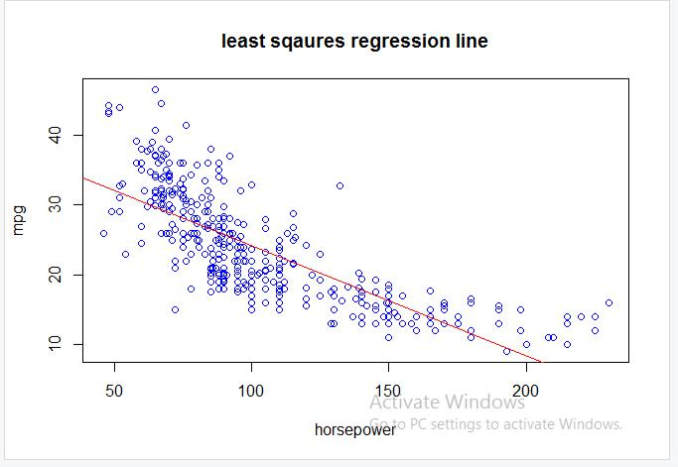
2.(c)

Use the plot() function to produce diagnostic plots of the least squares regression fit. Comment on any problems you see with the fit.

par(mfrow = c(2, 2))
plot(fit)
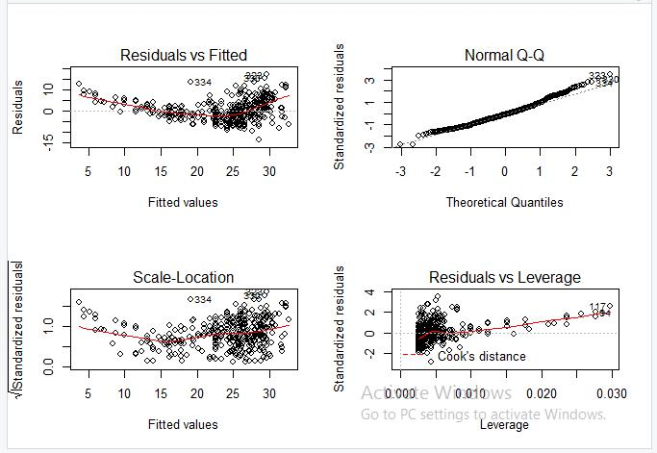
Question 3

- (a) Produce a scatterplot matrix which includes all of the variables in the data set. Pairs(Auto)
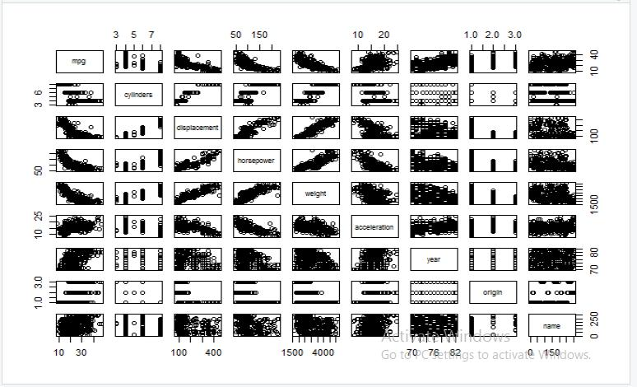

3.(b) Compute the matrix of correlations between the variables using the function cor(). You wil l need to exclude the name variable, which is qualitative.

names(Auto)

cor(Auto[1:8])
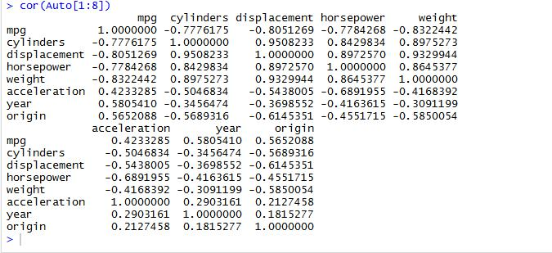

3.c.i

fit2 <- lm(mpg ~ . - name, data = Auto)
summary(fit2)
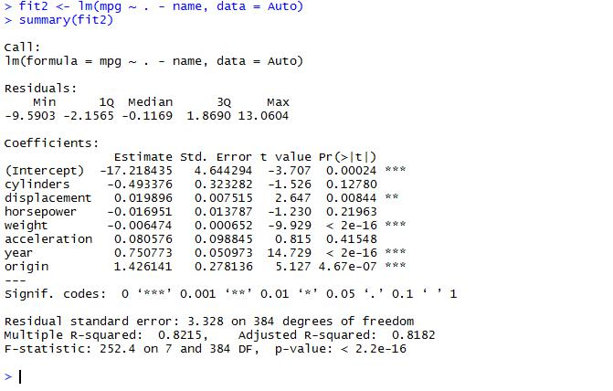

The p-value corresponding to the F-statistic is less than 2.2e-16 , this indicates that there is relationship between “mpg” and the other predictors.

3.c.ii

The P value for cylinder, horsepower, acceleration are near to 0 compared to the other components

3.c.iii

The ‘year’ variable coefficient indicates that for every one (1) year increase, the response variable `mpg` increases by 0.75.

3.d

par(mfrow = c(2, 2))
plot(fit2)
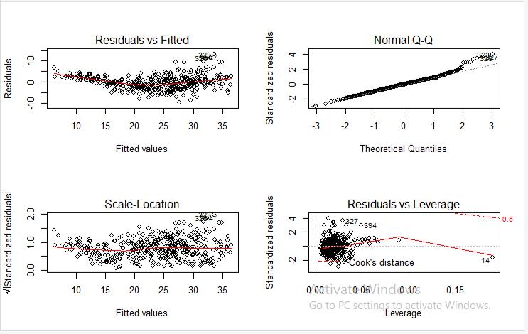

The Normal Q plot , largely shows that the residuals are normally distributed.
Point 14 is a high-leverage point in the residuals vs leverage graph.
3.e

fit3 <- lm(mpg ~ cylinders * displacement + displacement * weight, data = Auto[, 1:8])

summary(fit3)
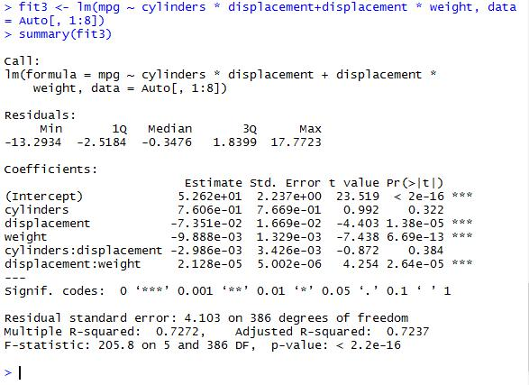

The interaction between displacement and weight is statistically significant, while the interaction between cylinders and displacement is not that significant.
3.f

lm.fit.1 <- lm(I(mpg^2) ~ cylinders + I(displacement^2) + I(horsepower^2) + sqrt(weight) + I(acce leration^2) + sqrt(year) + origin, data=Auto)

summary(lm.fit.1)
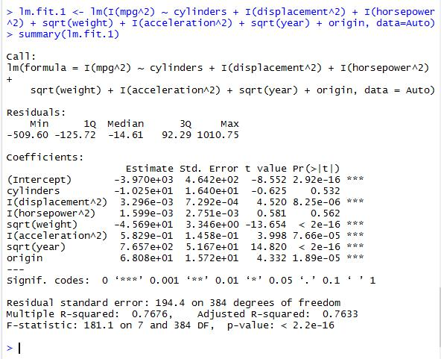

The differences noticed from the original model were: acceleration became a significant variable and displacements also decrease its p-value. Though the R2R2 decreases its value. The predictors year and weight had kept as the most important estimators.
Question 4

4.a

data("Carseats")

lm.fit.a <- lm(Sales ~ Price + Urban + US, data=Carseats)

summary(lm.fit.a)
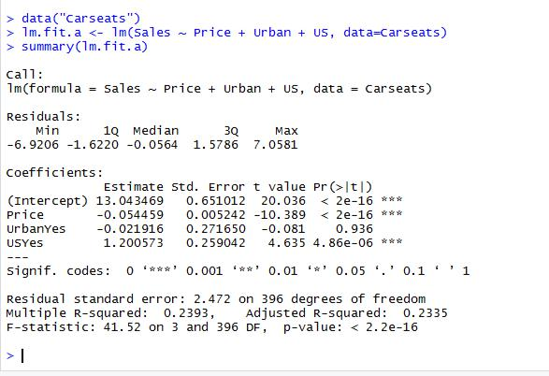

4.b

attach(Carseats)

str(data.frame(Price, Urban, US))
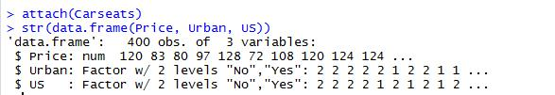

The Urban and US are qualitative

The “Price” coefficient variable may be interpreted by saying that the average effect of a price increase of 1 dollar is a decrease of 54.4588492 units in sales all other predictors remaining fixed. The coefficient of the “Urban” variable may be interpreted by saying that on average the unit sales in urban location are 21.9161508 units less than in rural location all other predictors remaining fixed. The coefficient of the “US” variable may be interpreted by saying that on average the unit sales in a US store are 1200.5726978 units more than in a nonUS store all other predictors remaining fixed.

4.c

Sales=13.0434689+(−0.0544588)×Price+(−0.0219162)×Urban+(1.2005727)×US+ε

If store I sin urban, then urban=1 else 0

If stire is in US , then us=1 else 0

4.d

We can reject the Null hypothesis for price and US variables

4.e

fit2 <- lm(Sales ~ Price + US, data = Carseats)
summary(fit2)
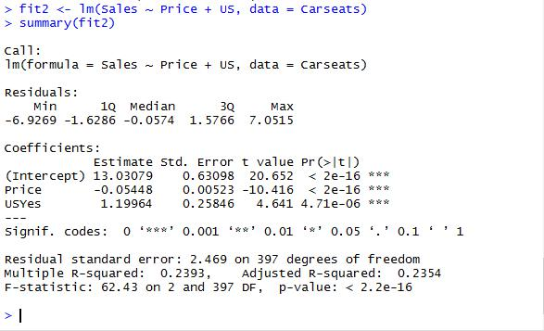
4.f

The R² for the smaller model is marginally better than for the bigger model. Essentially about 23.9262888% of the variability is explained by the model.

4.g

confint(fit2)
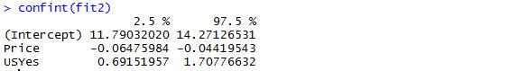

4.h

par(mfrow = c(2, 2))

plot(fit2)
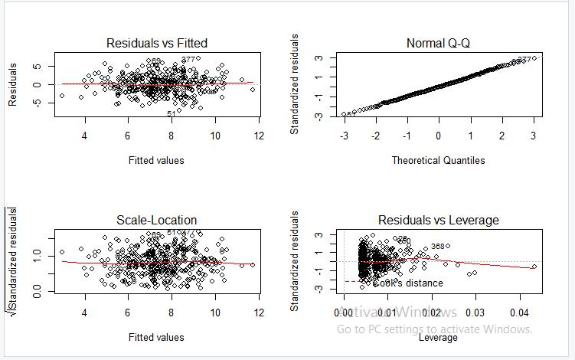

The residual Vs leverage shows the presence of outliers
Question 5
5.a
set.seed(1)
- <- rnorm(100)

- <- 2 * x + rnorm(100) fit5 <- lm(y ~ x + 0) summary(fit5)
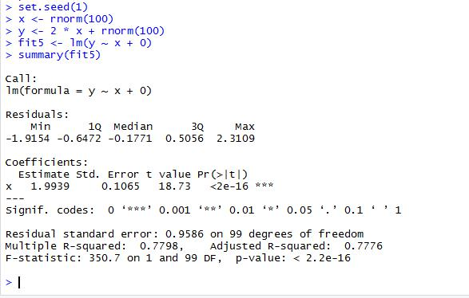

According to the summary above, we have a value of 1.9938761 for B^, a value of 0.1064767 fo

- the standard error, a value of 18.7259319 for the t-statistic and a value of 2.642196910^{-34} f or the p-value. The small p-value allows us to reject H0.
b.
fit6 <- lm(x ~ y + 0)
summary(fit6)
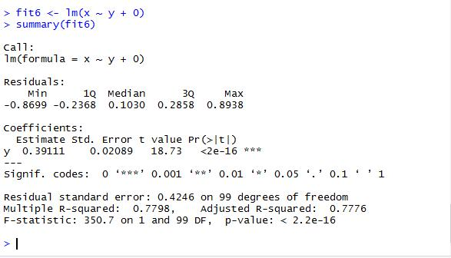

According to the summary above, we have a value of 0.3911145 for estimated std error, a value of 0.0208863 for the standard error, a value of 18.7259319 for the t-statistic and a value of 2.64 2196910^{-34} for the p-value. The small p-value allows us to reject H0.

5.c

We obtain the same value for the t-statistic and consequently the same value for the corresponding p-value. Both results in (a) and (b) reflect the same line created in (a). In other words, y=2x+ε could also be written x=0.5(y−ε).

5.d

n <- length(x)
t <- sqrt(n - 1)*(x %*% y)/sqrt(sum(x^2) * sum(y^2) - (x %*% y)^2)

as.numeric(t)
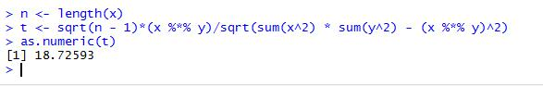

We may see that the t above is exactly the t-statistic given in the summary of “fit6”.
5.e

It is easy to see that if we replace xi by yi in the formula for the t-statistic, the result would be the same.

5.f

fit7 <- lm(y ~ x)
summary(fit7)
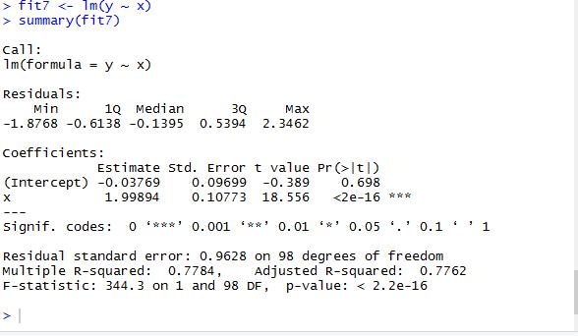

fit8 <- lm(x ~ y)
summary(fit8)
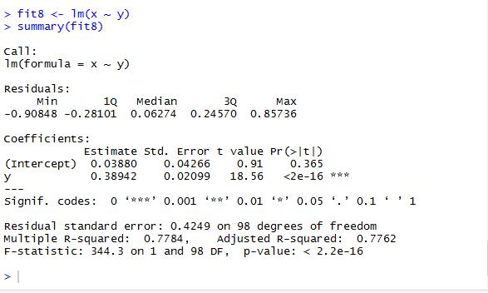

We can say that the t-statistic in both is equal to 18.5555993

